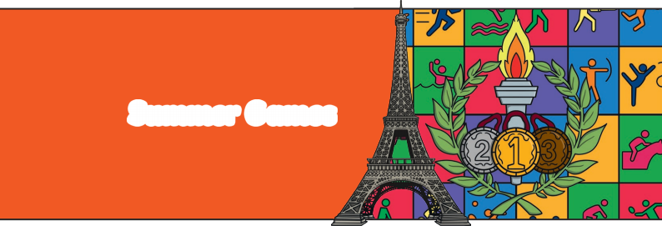
Paris

ESL

Summer Games


2024
1

Pre-reading Questions: Would you rather
• …win a gold medal for an individual sport or a team sport?
• …compete in the Summer Games or the Winter Games?
• …watch the Summer Games live in person or from the comfort of your own home?

Imagine … it is 13 September 2017 and Paris has just been selected as the host city for the next Summer Games. A loud applause can be heard from the crowd while the Paris officials hug and cheer
following the incredible news.
The 2024 Games will mark the third time Paris hosts this international sporting event, coming exactly 100 years after they last hosted the Games. What can people expect
from the Paris Summer Games? A memorable experience for athletes and spectators alike.
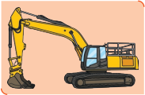
2
The Preparations
As the countdown ticks away, the city is making preparations
that will completely shift its urban landscape and infrastructure. Paris is working hard to breathe new life into its historic city
centre by cleaning up the Seine River, adding bike lanes, strengthening security, improving public transport, and restricting unnecessary traffic.
The French capital is set to open up 55km of new bike paths that connect venues in Paris to those in the northeast of the country. The goal is for visitors to be able to cycle around the city centre and reach all the Game sports sites on the map by summertime!
Paris Summer Games 2024

3 | 
What sports are included in the lineup?
At the Paris Summer Games 2024, spectators can look forward to a variety of events, from archery and marathon swimming
to taekwondo and mountain biking. Paris has taken the
opportunity to include four additional sports to enhance its programme and overall
concept. These sports are closely associated with youth and reward creativity and
athletic performance, including breakdancing and skateboarding. There will be both
experienced athletes and newcomers ready to show their skills. Each athlete represents their country and is determined to showcase the pinnacle of their abilities on the
international stage.

4
What about the medals?
In honour of the Games returning to France, every medal features a unique element from the Eiffel Tower as a special decoration!
Each medal has a piece of the original Eiffel Tower at its heart.
The iron is shaped in a hexagon– the geometrical shape of France, and is placed in the centre of the medal and imprinted with the emblem of the Paris Summer Games 2024. This piece of heritage fits perfectly within the gold, silver and bronze. The Eiffel Tower has also inspired the special design of the ribbons for the medals. The ribbons will be adorned with the Eiffel Tower latticework.

